Final Project

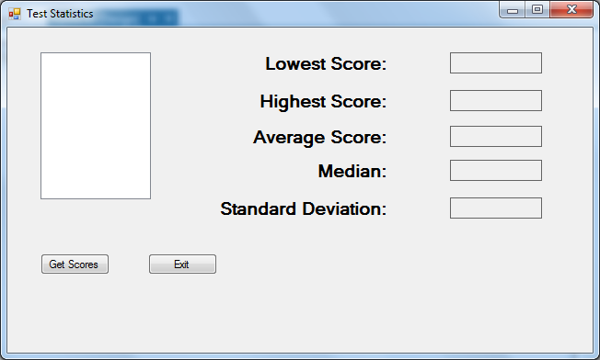

Create an application that reads a file called Test Scores.txt with 11 scores. Place the data in an array or list and display the content of the array or list in a listbox.

Write methods that accept an array or list and returns lowest score, highest score, median score, average score and the standard deviation of the scores.

Using the methods you created calculate the lowest score, highest score, median score, average score and the standard deviation of the scores. Display those values in the appropriate labels.

Note: the median is calculated differently if your data is odd or even. Ensure that your method can handle an even or odd number of data items.

